AWS Systems Manager
Create a new role in IAM service with policy:
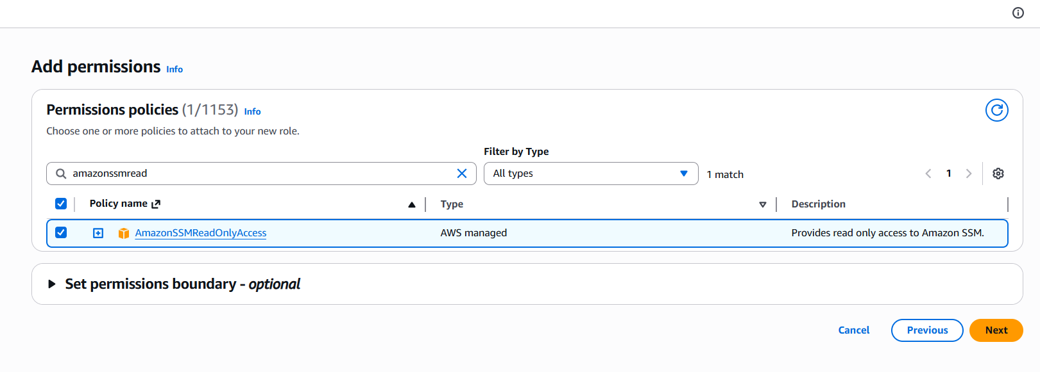
Role created with policies:
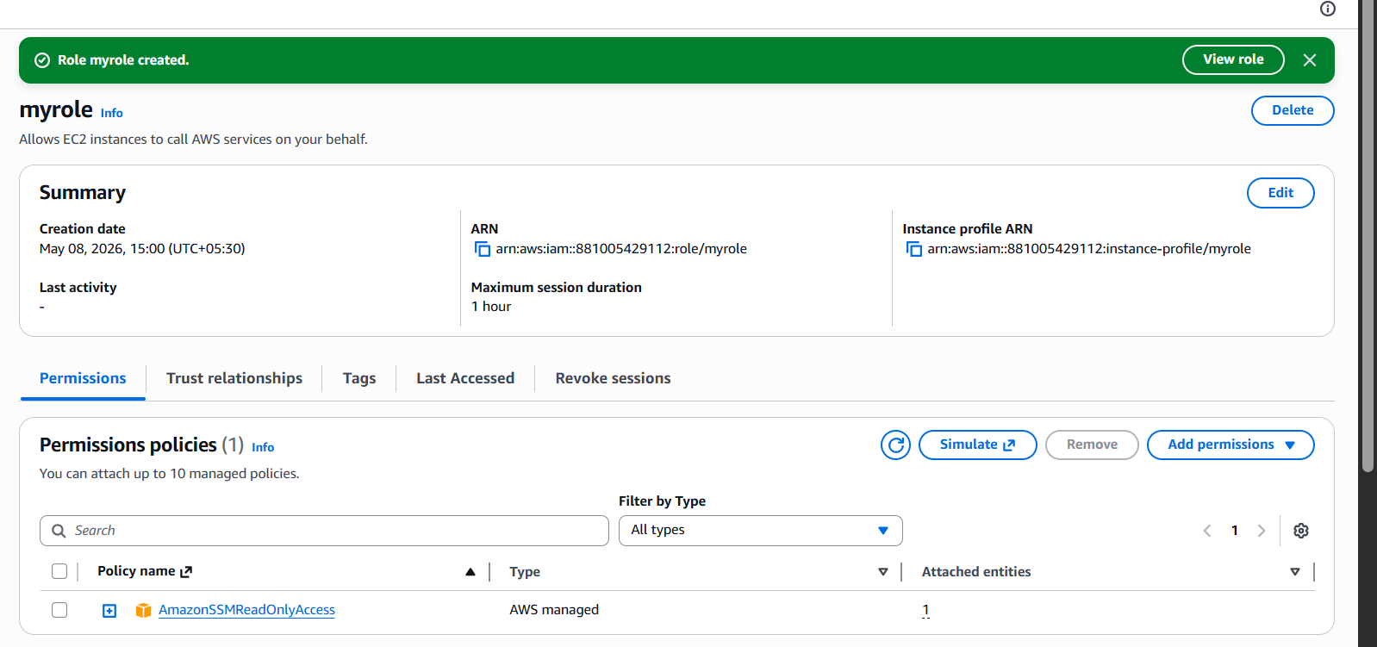
Created a new instance and attached vpc and subnet
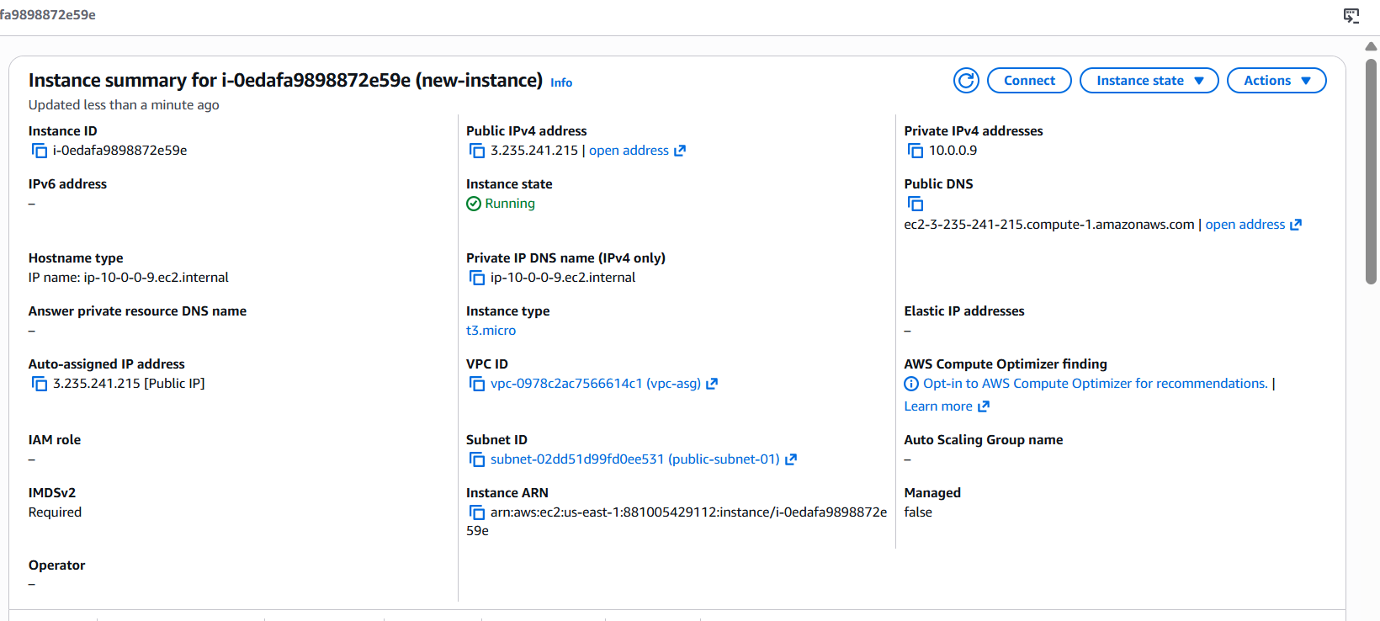
Connected with instance
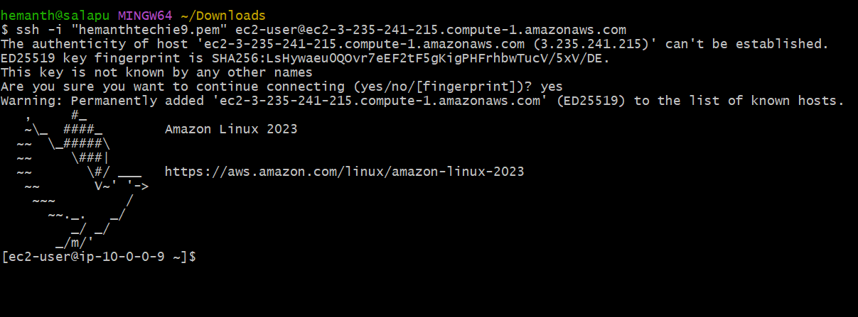
Created a new parameter in system manager:
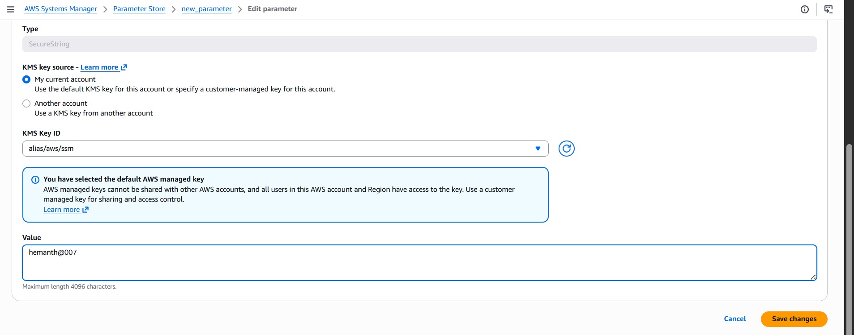
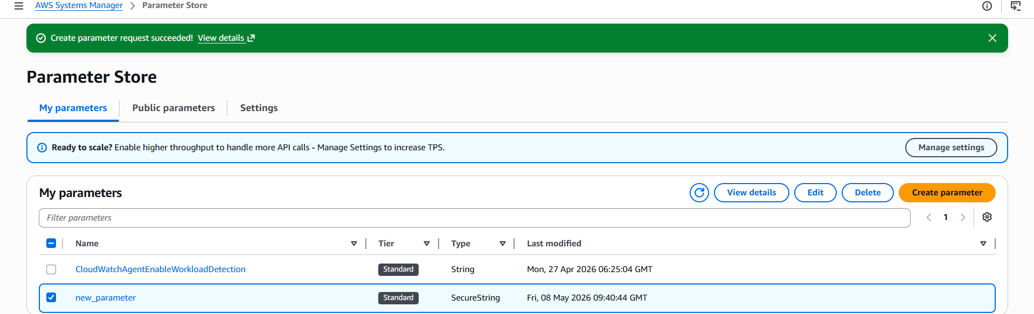
Value hemanth@007
Then the below command is used
aws ssm get-parameter \
--name "/new_parameter" \
--with-decryption
then got this output:
